MongoDB Task

**Design database for Zen class programme**

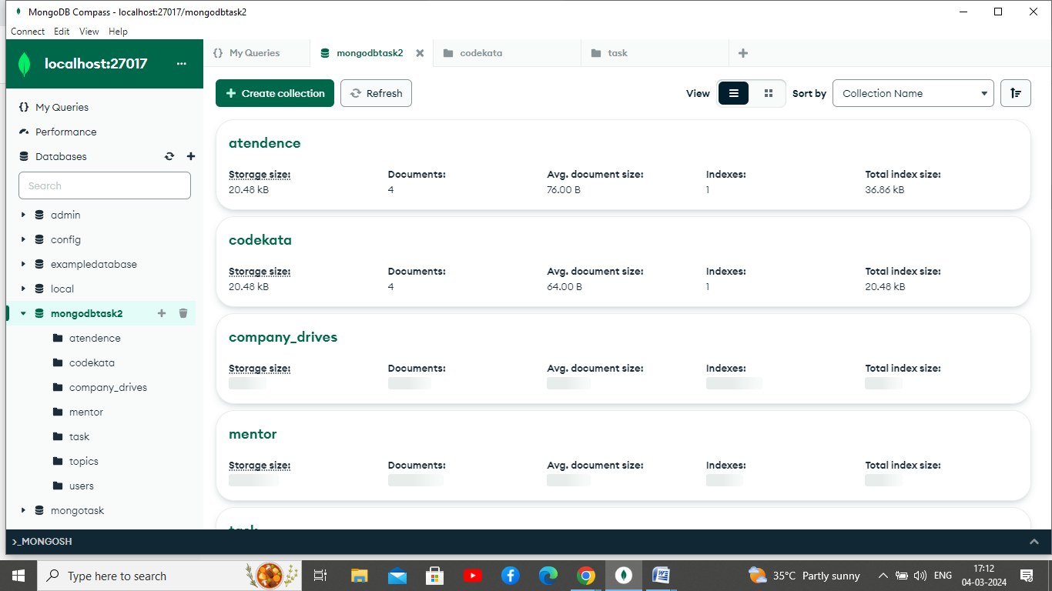

## 1. Find all the topics and tasks which are thought in the month of October

### Answer:

db.task.aggregate([

{

$lookup: {

from: "topics",

localField: "topic_id",

foreignField: "_id",

as: "topic"

}

},

{

$match: {

date: {

$gte: ISODate("2020-10-01T00:00:00Z"),

$lte: ISODate("2020-10-31T23:59:59Z")

}

}

},

{

$unwind: "$topic"

},

{

$project: {

_id: 1,

topic_id: 1,

topic_name: "$topic.name",

date: 1,

submitted: 1

}

}

]);

{

_id: ObjectId('65e5ad4324b76afd34847793'),

topic_id: ObjectId('65e59ee324b76afd3484778b'),

date: 2020-10-15T00:00:00.000Z,

submitted: false,

topic_name: 'Topic Name'

}

## 2. Find all the company drives which appeared between 15 oct-2020 and 31-oct-2020

### Answer:

db.company_drives.find({

"date": {

$gte: ISODate("2020-10-15T00:00:00Z"),

$lte: ISODate("2020-10-31T23:59:59Z")

}

})

3. Find all the company drives and students who are appeared for the placement.

### Answer:

db.company_drives.aggregate([

{

$match: {

date: {

$gte: ISODate("2020-10-15T00:00:00Z"),

$lte: ISODate("2020-10-31T23:59:59Z")

},

participants: { $exists: true, $not: { $size: 0 } }

}

},

{

$lookup: {

from: "users",

localField: "participants",

foreignField: "_id",

as: "appeared_students"

}

}

])

## 4. Find the number of problems solved by the user in codekata

### Answer:

var userId = ObjectId('65e58ab724b76afd34847779');

db.codekata.aggregate([

{

$match: {

user_id: userId,

problems_solved: { $exists: true, $ne: null, $gt: 0 }

}

},

{

$lookup: {

from: "user",

localField: "user_id",

foreignField: "_id",

as: "userDetails"

}

},

{

$unwind: "$userDetails"

},

{

$group: {

_id: "$userDetails._id",

userName: { $first: "$userDetails.name" },

userEmail: { $first: "$userDetails.email" },

totalScore: { $sum: "$problems_solved" }

}

},

{

$project: {

_id: 0,

userId: "$_id",

userName: 1,

userEmail: 1,

totalScore: 1

}

}

]).forEach(printjson);

## 5.Find all the mentors with who has the mentee's count more than 15

### Answer:

db.mentors.aggregate([

{

$project: {

mentor_id: "$_id",

menteeCount: { $size: "$mentees" }

}

},

{

$match: {

menteeCount: { $gt: 15 }

}

}

])

## 6. Find the number of users who are absent and task is not submitted  between 15 oct-2020 and 31-oct-2020

### Answer:

db.atendence.aggregate([

{

$match: {

date: {

$gte: ISODate("2020-10-15T00:00:00Z"),

$lte: ISODate("2020-10-31T23:59:59Z")

},

status: "absent"

}

},

{

$lookup: {

from: "tasks",

localField: "user_id",

foreignField: "user_id",

as: "userTasks"

}

},

{

$match: {

"userTasks": { $size: 0 }

}

},

{

$group: {

_id: null,

numberOfUsers: { $sum: 1 }

}

}

])